Men’s Saturday Morning Group

Join us for Lectio: Salvation

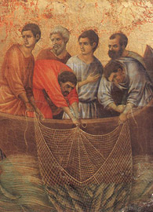

January 29 – April 1
7:15 - 8:30AM – Quad Rooms
Cost: $25
Registration deadline: January 25

Name: __________________________
Email: __________________________
Phone: __________________________
Make check payable to: Church of St. Michael 